Local area estimates and geographical patterns of Australia’s sexual minority population

Abstract
The need for subnational population statistics by sexual identity is being increasingly recognised for a variety of service delivery, analysis, and policy purposes. However, such statistics are rarely produced by statistical offices or researchers. The aims of the paper are to describe a new method for calculating subnational estimates of the population aged 18 and over by sexual identity, and apply it to produce mid-2016 estimates for local areas in Australia. Census counts of persons in same-sex and opposite-sex relationships, survey data by sexual identity and partnership status, and official Estimated Resident Population data are used. The method first involved preparing census-like counts of populations by sexual identity, and then scaling them using iterative proportional fitting to be consistent with local area Estimated Resident Populations and national estimates by sexual identity. We find that the geography of Australia’s sexual minority population is highly concentrated, with the highest proportions of the population identifying as a sexual minority in the inner areas of Australia’s largest cities. However, almost all parts of the county are home to at least a small sexual minority population, even in remote areas. While our estimates remain approximate due to data limitations, they provide a reasonable set of statistics on local area populations by sexual identity.

Key words
Sexual minority; population estimates; local area; geography; Australia

1. Introduction

The need for population statistics which include sexual identity (heterosexual, gay, lesbian, bisexual, and other sexualities) is increasingly being recognised by researchers, governments, community organisations, and national statistical offices (e.g. Churchill 2019; Gammarano 2019; ONS 2010). Population estimates by sexual identity can help assess demand for a range of services aimed at minority sexual groups, facilitate the monitoring of discrimination, and provide denominators for various rates and indicators. If sexual identity population estimates are available, difficulties and challenges reported by sexual minorities in sample surveys can be scaled up to the population as a whole. Population estimates can also provide data to calculate the number of people in minority sexual groups referred to by policy and legislation. Over the last decade in Australia, legislation has been introduced to ban discrimination on the basis of sexual orientation (Sex Discrimination Amendment Act 2013), enable marriage equality (Marriage Amendment Act 2017), and treat “lesbian, gay, bisexual, transgender and intersex people” as a special needs group under the Aged Care Act 1997. And for sexual minority populations themselves, being included in statistical reports provides a degree of visibility, and allows stereotypes and myths to be countered (Gates 2012). Given that population characteristics and needs are likely to vary geographically, there is a strong case for creating regional and local area population estimates by sexual identity.

Generally, sexual minority population estimates are not published by national statistical offices. The UK Office for National Statistics is a notable exception, having published experimental national and subnational sexual identity population estimates in recent years (ONS 2017, 2020). In the future, such estimates are likely to be more common as sexual identity questions are introduced into censuses and major national surveys. For example, the statistical offices of the UK and New Zealand will ask a question on sexual identity in their respective 2021 and 2023 censuses (Sherwood 2020; 1 News 2020). Unfortunately, it appears that a sexual identity question will not be included in the 2021 Census in Australia (ABS 2020a).

In the absence of official estimates, some researchers have calculated sexual minority population estimates for Australia. Using proportions of the population identifying as gay and bisexual from the Australian Study of Health and Relationships and census population counts, Prestage et al. (2008) produced estimates of the number of gay and bisexual men in Australia in 2001. Both national and state and territory estimates were prepared. Madeddu et al. (2006) presented 2001 estimates of the gay and bisexual male population in inner Sydney postcodes where there is a large resident sexual minority population. They used proportions from an oversample of the Australian Study of Health and Relationships in inner Sydney and applied those to 2001 Census counts. Author reference (2018) calculated estimates for 2016 using averaged proportions of the population identifying as a sexual minority from three surveys and multiplied these by Estimated Resident Populations (ERPs) at the national scale. State and territory estimates were created by distributing national estimates according to the number of people in same-sex couple relationships in the 2016 Census. National-level sexual minority estimates were recently updated in Author reference (2020a). In another new study, Callander et al. (2020) published estimates of gay and lesbian populations for postal areas across Australia. The authors used 2016 Census counts of persons in same-sex couples by postcode and then added estimated numbers of non-cohabiting gay men and lesbians. To calculate the non-cohabiting element of the population, survey data was used on the share of gay men and lesbians in cohabiting relationships for three broad region types (major cities, inner and outer regional areas, and remote and very remote areas). While an interesting method, the undercount of same-sex couples in the census will have impacted the resulting population estimates. The authors’ 2016 estimates suggest that at the national scale 1.5% of adult men and 0.9% of adult women were gay and lesbian, respectively, which are a little lower than percentages revealed by surveys (e.g. Richters et al. 2014; Wilkins 2015) and lower than the equivalent 2.0% (gay) and 1.1% (lesbian) figures estimated recently (Author reference 2020a).

A few estimates of sexual minority populations have been prepared for other countries. Gates (2011) has examined the limited data on the size of lesbian, gay and bisexual (LGB) or lesbian, gay, bisexual and transgender (LGBT) populations among a selection of largely western countries which collect the necessary survey data. In the US, the Williams Institute at University College Los Angeles maintains a research programme on LGBT demography and an interactive LGBT data dashboard. Using data sourced from the Gallup Daily tracking survey, their estimate of the US LGB adult population in 2017 is 10.3 million, equivalent to 4.1% of the population (Williams Institute 2020).

For many users, the ideal geography for sexual minority population estimates would be local areas and regions, permitting services to be allocated in line with the population distribution or distribution of need. But the creation of such estimates is not straightforward. Given that sexual minority populations exhibit large geographical variations in concentration (e.g. Forrest et al. 2019; Gates 2013) local area population estimates cannot simply be calculated by multiplying national proportions of the population identifying as sexual minorities by local area population estimates. Local level population estimates must account for geographical variation and be based on local level data and information.

In this paper we propose a method for calculating local area population estimates by sexual identity, modifying and building on the approach of Callander et al. (2020), and apply the method to produce estimates for mid-2016. The year 2016 was chosen because it is the year of the most recent census, the year of the most recent ABS finalised Estimated Resident Populations which will not be subject to later revision, and the year for which important survey data is available. We include people identifying as lesbian, gay, bisexual, queer and other non-heterosexual identities, collectively referring to these groups as the sexual minority population, and we also calculate estimates of the heterosexual population. Importantly, we ensure consistency with official ABS Estimated Resident Populations for local areas and recently published national level sexual minority population estimates (Author reference 2020a).

In terms of populations definitions, it is important to point out that most sexual minority population estimates are defined in terms of sexual identity, which in practice translates to how people report their sexual orientation in surveys. This will differ from sexual minority populations measured in other ways, such as people experiencing same-sex sexual attraction and or those engaging in same-sex sexual behaviour. Previous research has demonstrated substantial differences in population size are obtained depending on whether the definition is based on identity, behaviour or attraction (e.g. Richters et al. 2014; Mishel 2019). The population estimates prepared for this study are also defined by identity. Such estimates by definition therefore exclude those who experience same-sex attraction or activity but choose not to identify with a sexual minority identity (Gates 2012).

Regarding geography, our population estimates were prepared for SA3 areas of the Australian Statistical Geography Standard 2016 (ASGS) (ABS 2016), which were designed by the ABS to contain populations within the range 30,000 to 130,000. However, a few areas contain considerably smaller populations (such as some remote islands which cannot easily be grouped with other areas) while some urban areas contain populations above this range. SA3 areas were selected because this is the lowest level of geography for which available census data can provide reliable statistics by sex and broad age group. In addition, use of an official statistical geography such as SA3s permits easy comparison with the large amount of other statistical data published by the ABS for these areas, and also higher ASGS geographies to which SA3 areas aggregate up to perfectly (ABS 2016).

Following this introduction, we discuss data inputs and estimation methods, followed by a presentation of the population estimates and geographical patterns in section 3 along with a comparison against other data sources. An Excel file of our population estimates is also available for download on figshare.com at https://doi.org/10.6084/m9.figshare.13263872.v1. The final section of the paper includes a short discussion about the data and results, and what further research and data are needed.

2. Data and methods

2.1. Data

Four datasets were obtained to create the population estimates using the method outlined below. First, 2016 Census counts of people in same-sex couple relationships were obtained via the online data extraction tool TableBuilder Pro (ABS 2020b). We extracted counts of persons by sex and broad age groups 18-34, 35-54, and 55+ by SA3 region (n=338), which was as detailed a disaggregation as possible to ensure non-zero counts in most cells. Second, ABS Estimated Resident Populations (ERPs) for SA3 areas in 2016 by sex and five year age group were obtained from the ABS.Stat website (ABS 2020c). The 18-19 part of the 18-34 broad age group was estimated by taking 0.4 of the published 15-19 age group ERP. Third, updated 2016 national sexual minority population estimates by broad age group and sex recently prepared by Author reference (2020a) were used. Finally, we extracted national scale HILDA (Household, Income and Labour Dynamics in Australia) survey data to calculate the ratio of sexual minority individuals in a cohabiting relationship in 2016 to those who were single. HILDA is a large scale representative longitudinal study covering about 17,000 households each year (Wilkins et al. 2019).

2.2. Methods

SA3 area population estimates for the sexual minority population were generated in two main stages. In the first stage, preliminary estimates of the sexual minority and heterosexual adult populations were created from census counts. These preliminary census-based numbers are undercounts, but likely provide a reasonable initial geographical distribution. In the second stage, the preliminary estimates were scaled up to be consistent with official SA3 Estimated Resident Populations published by the ABS and national sexual minority population estimates prepared earlier (Author reference 2020a).

In the first stage, census-based estimates of the sexual minority population were calculated as:
$C_{i,s,a}^{mty} = C_{i,s,a}^{mty,cr}+ C_{i,s,a}^{mty,sing}$ (1)
where $C$ denotes a census count of persons, $mty$ sexual minority, $cr$ in a cohabiting relationship, $sing$ single, $i$ SA3 area, $s$ sex and $a$ age group. The first term on the right-hand side of the equation is the number of sexual minority individuals in a cohabiting relationship, approximated by the number of people counted in the census in a same-sex cohabiting relationship. The latter is derived from answers to census questions on gender and relationship between persons in a household. It is only an approximate count of the partnered sexual minority population because it omits bisexual people who are in opposite-sex relationships (Kuhne et al. 2019). The second term on the right-hand side refers to the number of single people who identify as a sexual minority. This is not measured by the census and is estimated using additional data and assumptions.

The proportion of single people with a sexual minority identity is assumed to be a function of the proportion of all people in cohabiting relationships who are in a same-sex relationship. This proportion represents a proxy indicator of the attractiveness of a local area to the sexual minority population generally. This is a key assumption of our approach. As described in equation 2 below, the single sexual minority population is estimated as the product of the single population and the proportion of all partnered individuals in the SA3 area who are in a same-sex relationship, which is then multiplied by a ratio which ensures that the results sum to a separate national census-like estimate of the sexual minority single population:
$C_{i,s,a}^{mty,sing} = C_{i,s,a}^{sing} p_{i,s,a}^{mty,cr} \frac{C_{Aus,s,a}^{mty,sing}}{\sum_{i}{\left(p_{i,s,a}^{mty,cr} C_{i,s,a}^{sing}\right)}}$ (2)
where $p$ refers to the proportion of partnered individuals in a same-sex relationship and $Aus$ to Australia. The product of the second and third terms on the right-hand side of equation 2 can be interpreted as the proportion of the local single population who identify as a sexual minority. Note that the geographical distribution of the single sexual minority population calculated in this way differs to some extent from the distribution of persons in same-sex relationships.

The national estimate of the sexual minority single population in equation 2 is calculated using a ratio of sexual minority individuals who are single to those who are in same-sex cohabiting relationships, which is based on HILDA survey data. This ratio forms the second term on the right-hand side of equation 3 below. The ratio is then multiplied by census counts of persons in same-sex relationships. This gives census-like estimates of the national sexual minority single population:
$C_{Aus,s,a}^{mty,sing} = C_{Aus,s,a}^{mty,ssr} \frac{S_{Aus,s,a}^{mty,sing}}{S_{Aus,s,a}^{mty,ssr}}$ (3)
where $S$ denotes national level survey-based estimates.

Our estimation method also requires SA3 area heterosexual population numbers. A census-like estimate of the heterosexual population is calculated as the number of people in heterosexual cohabiting relationships plus the single population who do not identify as a sexual minority:
$C_{i,s,a}^{hs} = C_{i,s,a}^{hs,cr}+ \left(C_{i,s,a}^{sing}- C_{i,s,a}^{mty,sing}\right)$ (4)
where $hs$ refers to heterosexual. In addition to the approximation inherent in the estimation of the heterosexual single population as a residual in this equation, the use of census counts of those in opposite-sex cohabiting relationships to represent the heterosexual cohabiting population is also imperfect. A very small proportion of people in opposite-sex relationships are bisexual (Kuhne et al. 2019).

The census-based estimates of the sexual minority population calculated in this way will be substantial undercounts. There are several reasons why, in addition to the omission of bisexual people in opposite-sex relationships noted above. The census suffers from underenumeration, i.e. it misses a small proportion of the population every time it is held (ABS 2017). In addition, there is item non-response, which refers to particular questions not being answered by those who do submit a census form (ABS 2018a). And some information is missed or omitted in answers to some census questions. In particular, partner relationships are only captured by the census if one partner is listed as ‘person 1’ on the census form (ABS 2017), and some people in same-sex relationships may choose not to report their relationship status in the census. In addition, census data on relationships between people in households is made available only for those counted at their usual residence on census night (thus excluding the sizeable number of people temporarily away from home). Furthermore, people enumerated in institutional accommodation do not get the opportunity to report relationships in the census. But while the census-based preliminary estimates cannot be viewed as accurate estimates of the sexual minority resident population, they represent the best available geographical distribution by subnational area and age group.

In the second stage of the estimation process, the census-based estimates are constrained to sum to both:
(i) SA3 area ERPs by sex and broad age group, and
(ii) national-level population estimates by sexual identity (sexual minority or heterosexual), sex and broad age group
using iterative proportional fitting (Lomax and Norman 2016). The 2016 national sexual minority population estimates for those aged 18+ are 651,800 (or 3.5% of the adult population), with the female population being 323,500 (3.4% of the adult female population) and the male population 328,300 (3.6%) (Author reference 2020). This estimation approach therefore provides a set of local area population estimates by sexual identity which draws upon several valuable data sources: spatial detail on the sexual minority population captured in census data, survey data on the ratio of single to cohabiting sexual minority populations, local area ERPs, and national-level sexual identity population estimates. The inclusion of the heterosexual population is essential to achieving consistency with local area ERPs, and also permits sexual minority shares of local area populations to be calculated.

3. Sexual minority population estimates and geographies

3.1. SA3 area geography

The estimated sexual minority population aged 18 and over in 2016 varies from zero in a handful of SA3 areas with very small populations up to 53,700 in Sydney Inner City, an area with a total adult population of 207,200 which contains the central business district of Sydney and adjacent inner suburbs. Mid-2016 population estimates by sexual identity (sexual minority and heterosexual) and sex for SA3 areas are available in the Supplementary Information accompanying this paper.

To describe the geography of Australia’s sexual minority population, we focus mainly on the estimated share of the adult population in each SA3 area identifying as a sexual minority. The shares by SA3 area in 2016 are shown in Figure 1. Areas with below-average percentages are shown in blue, while above-average percentages are depicted by the pink-orange-red palette. As can be seen, much of the geographical extent of Australia contains SA3 areas with below-average sexual minority shares. A little under a quarter of SA3 areas (22.8%) contain above-average sexual minority percentages for males, while for females it is almost a quarter (24.6%) of SA3 areas, but most of these are geographically small areas located in metropolitan regions which are hard to discern on a map covering the whole of the country.

We therefore present more detailed maps for the three most populous metropolitan regions in Australia – Sydney, Melbourne, and South East Queensland, which contains the city of Brisbane in the centre and Gold Coast just to the south. Figure 2 shows the patterns for females, while Figure 3 shows the equivalent for males. For females in the Sydney region, the highest sexual minority percentages can be found in the inner suburbs and also the outer western Sydney region of the Blue Mountains (8.1%). The highest percentage (the only area shaded red) is the inner city SA3 area of Marrickville – Sydenham – Petersham (19.5%), followed by Sydney Inner City (14.7%). In Melbourne, above-average percentages are found in inner/middle ring suburbs, with the highest being in Darebin – South (17.8%) which is the only area shaded red in the Melbourne map in Figure 2. Just to the west of Melbourne, the area shaded pink is Creswick – Daylesford – Ballan SA3 (7.3%), which contains the socially progressive town of Daylesford long known for being LGBTQ-friendly (Gorman-Murray et al. 2012). For South East Queensland, the inner and northern areas of Brisbane are most attractive to female sexual minority populations, with the highest percentage being for Brisbane Inner SA3 (8.4%), which contains the central business district and the more LGBTQ-friendly inner suburbs of Fortitude Valley, New Farm and West End.

Figure 3 shows that the broad pattern is similar for males, though it is slightly more geographically concentrated. In Sydney, the highest concentrations are found in Sydney Inner City (36.2%) and Marrickville – Sydenham – Petersham (20.8%). In Melbourne, the inner/middle suburbs of the city are generally most attractive to sexual minority males, with the highest shares of the population being found in the SA3 areas of Yarra (19.9%), Stonnington – West (18.8%), Port Phillip (17.1%), and Melbourne City (15.9%), which contains the central business district and a relatively young residential population. In South East Queensland, the highest percentage is in Brisbane Inner (15.1%), though the sexual minority shares fall within the 7-15% category in many neighbouring areas. In the SA3 of Surfer’s Paradise in the Gold Coast (the area shaded orange to the south of Brisbane in the South East Queensland map), the male sexual minority population comprises 7.5% of the total adult population.

There are a few other parts of Australia, not shown in Figures 2 and 3, where the sexual minority population comprises an above-average share of the population. Primarily these areas are located in the inner parts of large cities. In the Australian Capital Territory (Canberra), the sexual minority population in the SA3 of North Canberra comprises 12.2% of the female population and 10.9% of the male population. In Adelaide City, covering the central business district of Adelaide, the male sexual minority share is 14.0% while for females it is 7.6%. In Western Australia, Perth City SA3 contains the highest share of sexual minority males (11.1%) and females (6.2%). In the southern island state of Tasmania, the highest female share is in Hobart Inner (6.6%) while for males it is South East Coast (7.4%). In the Northern Territory, the highest male figure is in Darwin City (6.1%), the inner parts of the Northern Territory capital city, but for females it is in the outback town of Alice Springs (6.6%).

As the maps in Figures 1 to 3 reveal, Australia’s sexual minority population is highly geographically concentrated within a total population that is itself heavily concentrated near the coast and in the major cities. To obtain a measure of the extent of concentration, we calculated the Hoover Index (Hoover 1941; Rogerson and Plane 2013) for sexual minority and heterosexual adult populations. The index $H$ is defined as:
$H=50 \sum_{i}{\left|p^{i}-a^{i}\right|}$
where $i$ refers to any subnational area, $p$ the share of national population living in area $i$, and $a$ the share of national geographical area covered by $i$. The index ranges from a minimum of 0 (an even distribution of population and area) to a maximum of 100 (complete concentration). The index is equal to the percentage of the population that would need to be re-distributed across subnational areas to obtain an equal distribution of population and area. Note that the index is specific to the geography selected for analysis. For sexual minority females the Hoover index is 90.3, while for males the index value of 92.5 indicates slightly greater geographical concentration. For the heterosexual population, the index reveals a high degree of concentration, though less than that for the sexual minority population, and similar values for males (86.1) and females (86.7).
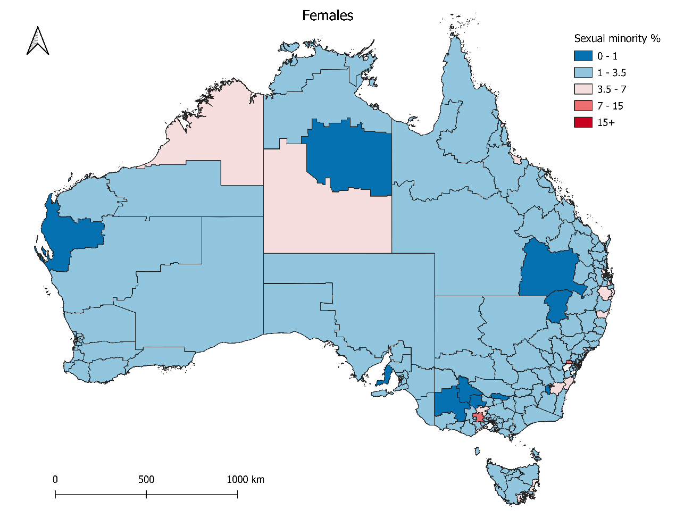
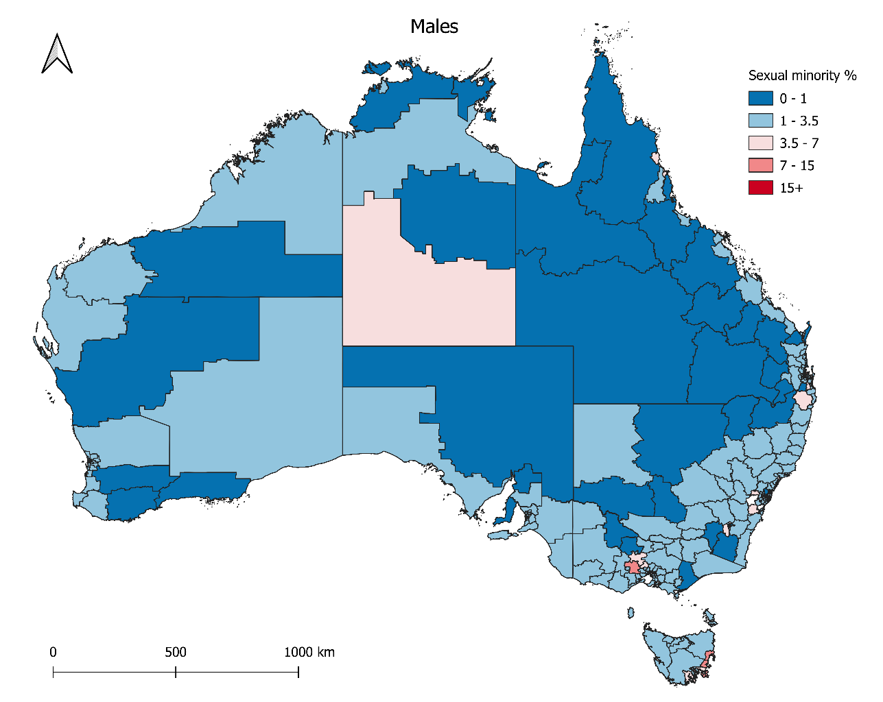
Figure 1: Estimated percentage of the adult population identifying as a sexual minority, 2016
Source: authors’ estimates

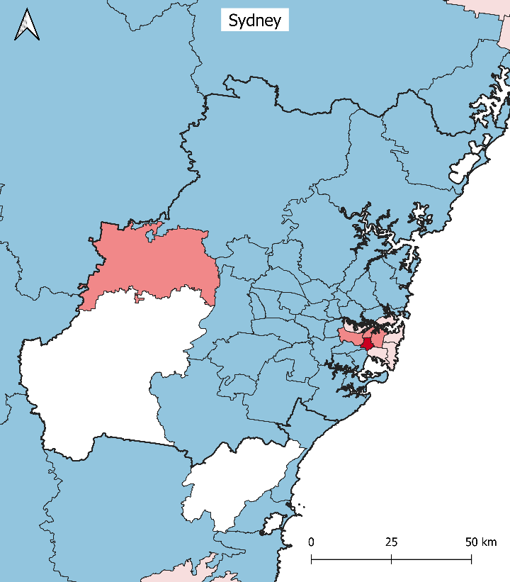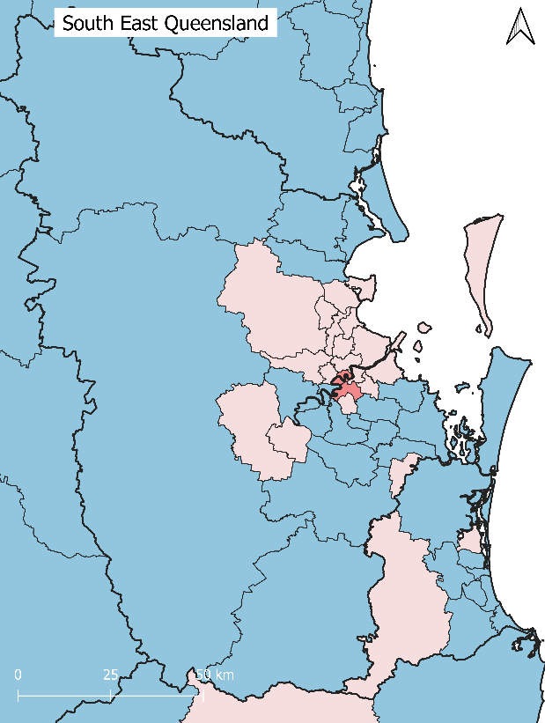
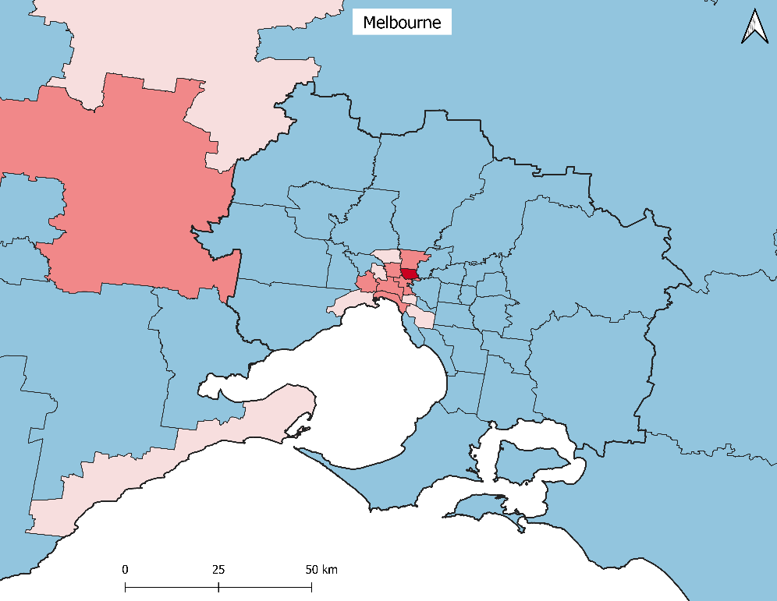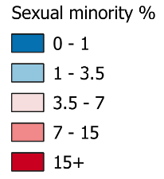
Figure 2: Estimated percentage of the female adult population identifying as a sexual minority in Sydney, Melbourne, and South East Queensland, 2016
Source: authors’ estimates
Note: Thick black lines indicate the boundaries of greater metropolitan regions. Areas shaded white in the Sydney map have no data (due to almost no population).

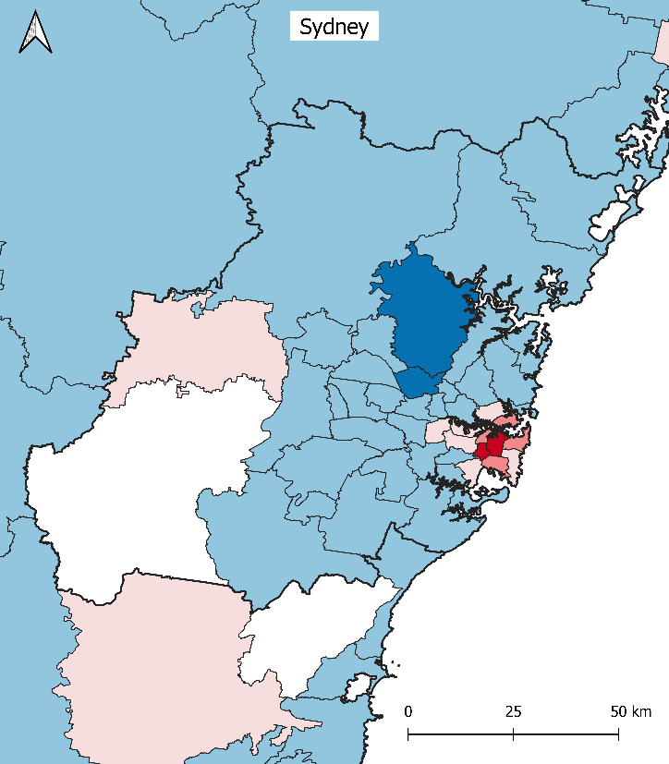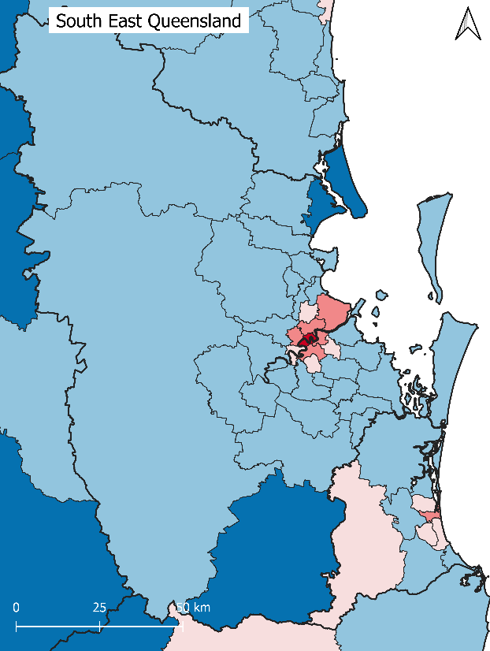
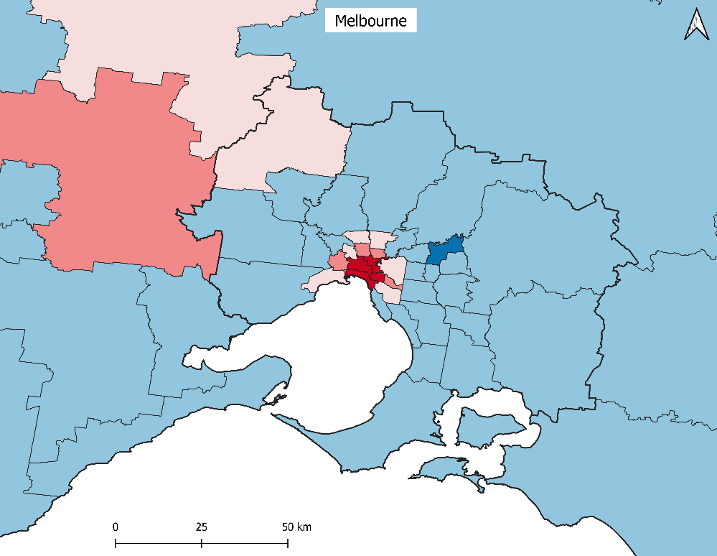
Figure 3: Estimated percentage of the male adult population identifying as a sexual minority in Sydney, Melbourne, and South East Queensland, 2016
Source: authors’ estimates
Note: Thick black lines indicate the boundaries of greater metropolitan regions. Areas shaded white in the Sydney map have no data (due to almost no population).

3.2. Other geographies

Table 1 presents sexual minority population estimates aggregated up from SA3 areas to three selected geographies: States and Territories, Greater Capital City Statistical Areas (GCCSAs), and Remoteness Areas. GCCSAs divide states and territories into two broad regions: the greater capital city metropolitan region and the rest of the jurisdiction (except for the Australian Capital Territory, which effectively contains only the national capital city of Canberra). Remoteness Areas were designed by the ABS to “divide Australia into 5 classes of remoteness on the basis of a measure of relative access to services” (ABS 2020d) and are a more nuanced version of the old urban versus rural dichotomy. The categories are Major Cities, Inner Regional (generally smaller cities and areas within a few hours’ drive of major cities), Outer Regional (smaller cities and larger towns far from major cities), Remote, and Very Remote. SA3 areas aggregate perfectly to States and Territories and GCCAS; aggregation to Remoteness Areas was achieved with a population-weighted concordance file (ABS 2018b) because Remoteness Area boundaries cut through SA3 areas.

Not surprisingly, the most populous states of New South Wales, Victoria and Queensland are home to the largest sexual minority populations, while the jurisdiction with the smallest population, the Northern Territory (with just under ¼ million residents), has the smallest sexual minority population. As a percentage of the total resident population, New South Wales, Victoria, and the Australian Capital Territory have above-average sexual minority percentages for males, while for females it is the same three states and territories plus the Northern Territory.

At the GCCSA scale, the largest sexual minority populations are present in the larger capital cities of Sydney, Melbourne and Brisbane, as would be expected. As a share of population, the highest percentage for females is found in the Australian Capital Territory (5.5%), followed by the Rest of Northern Territory (4.2%), and Brisbane (4.0%). For males, the equivalent areas are Sydney (5.3%), the Australian Capital Territory (4.8%), and Melbourne (4.5%). Mostly, the greater capital city regions are home to higher percentages of sexual minority populations than rest of state regions. This applies less to females than males, and the capital city / rest of state difference in percentages is generally smaller for females. Indeed, for the Rest of Northern Territory region the female sexual minority population (4.2%) actually comprises a higher percentage of the total adult population than the Northern Territory capital city of Darwin (3.3%).

Across the Remoteness Areas, the majority of Australia’s population, and its sexual minority population, live in Major Cities, with very small sexual minority populations present in Remote and Very Remote areas. The main difference occurs in how the sexual minority percentages vary across remoteness categories between males and females. There is a strong gradient for males, indicating a clear preference in favour of Major Cities and away from remote areas, while for females there is also a preference for Major Cities, but much less of a difference in percentages across other remoteness area types.

Table 1: Sexual minority adult population estimates by selected geographies, 2016
 | Population estimates |  |  | Percentage of population
 | Females | Males | Persons | Females | Males | Persons
States/Territories
New South Wales | 105,600 | 124,500 | 230,100 | 3.5 | 4.2 | 3.8
Victoria | 88,100 | 92,000 | 180,100 | 3.6 | 3.9 | 3.7
Queensland | 61,900 | 54,500 | 116,300 | 3.3 | 3.0 | 3.1
South Australia | 21,200 | 16,700 | 37,900 | 3.1 | 2.5 | 2.8
Western Australia | 28,400 | 25,200 | 53,600 | 2.9 | 2.6 | 2.7
Tasmania | 6,300 | 5,700 | 12,000 | 3.0 | 2.9 | 3.0
Northern Territory | 3,200 | 2,500 | 5,700 | 3.7 | 2.6 | 3.1
Australian Capital Territory | 8,700 | 7,300 | 16,000 | 5.5 | 4.8 | 5.1
GCCSAs
Greater Sydney | 73,600 | 101,700 | 175,400 | 3.7 | 5.3 | 4.5
Rest of NSW | 32,000 | 22,700 | 54,700 | 3.0 | 2.2 | 2.6
Greater Melbourne | 72,300 | 80,800 | 153,100 | 3.8 | 4.5 | 4.2
Rest of Victoria | 15,800 | 11,200 | 27,000 | 2.7 | 2.0 | 2.4
Greater Brisbane | 36,500 | 33,800 | 70,200 | 4.0 | 3.8 | 3.9
Rest of Queensland | 25,400 | 20,700 | 46,100 | 2.6 | 2.2 | 2.4
Greater Adelaide | 18,400 | 15,000 | 33,500 | 3.5 | 3.0 | 3.2
Rest of South Australia | 2,800 | 1,600 | 4,400 | 1.8 | 1.1 | 1.4
Greater Perth | 24,000 | 22,500 | 46,500 | 3.1 | 2.9 | 3.0
Rest of Western Australia | 4,300 | 2,700 | 7,000 | 2.2 | 1.3 | 1.7
Greater Hobart | 3,600 | 3,100 | 6,700 | 4.0 | 3.6 | 3.8
Rest of Tasmania | 2,700 | 2,600 | 5,300 | 2.3 | 2.3 | 2.3
Greater Darwin | 1,700 | 1,900 | 3,600 | 3.3 | 3.1 | 3.2
Rest of Northern Territory | 1,500 | 600 | 2,100 | 4.2 | 1.8 | 3.0
Australian Capital Territory | 8,700 | 7,300 | 16,000 | 5.5 | 4.8 | 5.1
Remoteness Areas
Major Cities | 252,800 | 277,300 | 530,100 | 3.7 | 4.2 | 3.9
Inner Regional | 47,600 | 34,400 | 82,000 | 2.8 | 2.1 | 2.4
Outer Regional | 18,600 | 14,300 | 32,900 | 2.4 | 1.8 | 2.1
Remote | 2,600 | 1,500 | 4,100 | 2.5 | 1.3 | 1.9
Very Remote | 1,800 | 900 | 2,700 | 2.6 | 1.1 | 1.8
National
Australia | 323,500 | 328,300 | 651,800 | 3.4 | 3.6 | 3.5
Source: authors’ estimates
Note: Estimates have been rounded to the nearest 100.

3.3. Comparison with other population estimates and indicators

How do our sexual minority population estimates, and in particular their geographical distribution, compare to other estimates and relevant indicators? Undertaking a comparison such as this forms part of a simple (albeit approximate) validation of our estimates. Unfortunately, there is little available data, and what data is available does not always provide an ideal comparison dataset. However, at the State and Territory scale it is possible to undertake a ballpark comparison with a few other datasets. Because of large variations in absolute numbers between datasets, we compare the percentage distribution of our new population estimates across jurisdictions with (i) earlier mid-2016 population estimates created by Author reference (2018), (ii) mid-2016 estimates of gay men and lesbian women prepared by Callander et al. (2020), (iii) sexual minority estimates from the 2014 General Social Survey (ABS 2015), (iv) sexual minority estimates from the 2016 wave of the HILDA survey (HILDA survey 2020), and (v) same-sex marriages registered in 2018 (ABS 2019). Table 2 presents the distributions.

Table 2: State and Territory distributions of sexual minority adult population estimates and marriage statistics
State/Territory | Our 2016 estimates | Author reference 2016 estimates | Callander et al. 2016 estimates | GSS 2014 survey | HILDA 2016 survey | Same-sex marriages in 2018
Females |  |  |  |  |  | per cent
New South Wales | 32.7 | 31.5 | 32.3 | 31.1 | 28.1 | 32.5
Victoria | 27.2 | 26.0 | 26.9 | 32.6 | 27.2 | 24.2
Queensland | 19.1 | 20.5 | 19.7 | 17.0 | 23.4 | 21.1
South Australia | 6.6 | 6.7 | 6.6 | 4.5 | 7.0 | 6.4
Western Australia | 8.8 | 9.6 | 9.1 | 10.6 | 9.0 | 10.5
Tasmania | 1.9 | 1.9 | 1.8 | 1.6 | 2.1 | 2.5
Northern Territory | 1.0 | 0.8 | 0.9 | 1.1 | 1.2 | 0.7
Australian Capital Territory | 2.7 | 3.0 | 2.8 | 1.5 | 1.9 | 2.1
Total | 100.0 | 100.0 | 100.0 | 100.0 | 100.0 | 100.0
Males
New South Wales | 37.9 | 37.9 | 39.3 | 42.3 | 32.6 | 38.5
Victoria | 28.0 | 27.1 | 27.9 | 24.3 | 20.1 | 26.6
Queensland | 16.6 | 17.4 | 16.6 | 15.7 | 26.1 | 18.1
South Australia | 5.1 | 5.1 | 4.6 | 7.5 | 4.3 | 5.2
Western Australia | 7.7 | 7.6 | 7.3 | 5.2 | 10.4 | 7.4
Tasmania | 1.8 | 1.8 | 1.5 | 2.7 | 3.9 | 1.6
Northern Territory | 0.8 | 0.8 | 0.6 | 0.9 | 1.2 | 0.7
Australian Capital Territory | 2.2 | 2.4 | 2.3 | 1.4 | 1.4 | 1.9
Total | 100.0 | 100.0 | 100.0 | 100.0 | 100.0 | 100.0
Sources: authors’ estimates, Author reference (2018), Callander et al. (2020), ABS (2015), HILDA survey (2020), ABS (2019)
Notes: HILDA and GSS survey data are weighted. ABS same-sex marriage data refer to the State/Territory where the marriage occurred.

Given that all the comparison datasets in the table vary in population definitions, dates, and have their own limitations, differences with the distribution of our population estimates do not automatically mean our estimates are unreliable, though large discrepancies might indicate problems. The Callander et al. estimates cover only part of the sexual minority population – gay men and lesbian women – and thus exclude bisexual and other minority sexual identities. GSS and HILDA estimates are based on samples and are subject to sampling error. The distribution of same-sex marriages is affected by the data being recorded by state or territory where the marriage occurred (not necessarily where the couple usually live), differences in population age structure between the states and territories (because marriage rates vary by age) and probably also some geographical variation in marriage rates. For males, our population estimates are closest in distribution to Author reference (2018), followed by Callander et al. (2020), and then same-sex marriages (ABS 2019). There are greater differences with the GSS and HILDA survey distributions. For females, our estimates are closest in distribution to those of Callander et al. (2020) and then Author reference (2018), but there are larger differences for same-sex marriages and the two surveys.

The State and Territory distribution of our sexual minority population estimates therefore appears free from major problems from the limited comparative analysis possible. For sub-state geographies, data and information for comparison are scarce, and their geographical and population coverage is limited relative to our estimates. We mention two data sources here. We don’t compare against 2016 Census counts of persons in same-sex cohabiting relationships because that data was integral to the creation of our population estimates and is highly correlated with them.

The first alternative data source is the Victorian Population Health Survey 2017 (Victorian Agency for Health Information 2020), which collected a variety of health and demographic information, including sexual identity, from 34,000 participants across the state of Victoria in 2017. The data are reported for the LGBTIQ+ population (sample size 1,300), which is a slightly wider definition than we use as it includes people reporting transgender, intersex, and asexual identities. It is also published for various administrative geographies, but not SA3 areas and other ABS statistical geographies. The study found that 6.0% of the adult population in Melbourne reported an LGBTIQ+ identity, while 4.5% in the Rest of Victoria did so. These are higher percentages than in our dataset, but broadly consistent with our GCCSA results in the sense of a higher metropolitan percentage. The study also found that the inner Melbourne local government areas of Darebin, City of Melbourne, Moreland, Port Phillip, and Yarra, had significantly higher proportions of the population with LGBTIQ+ identities than the State as a whole. Only the council of Manningham had a significantly lower percentage. These above-average and below-average areas align well with the distributions shown for Melbourne in Figures 2 and 3.

The other data source includes population estimates for gay and bisexual men in postcodes of central Sydney, although the data is now quite old (Maddedu et al. 2006). For those postcodes which fall within the Sydney Inner City SA3, 24% of adult men were estimated to be gay or bisexual in 2001. This is lower than the 36% we estimated for the male sexual minority population for Sydney Inner City, though the population coverage is a little different (it excludes ‘other’ sexual minorities), the time between the 2001 and 2016 reference dates is considerable, and the postcodes considered by the authors did not cover the entirety of this SA3 area. So, although the comparison is very approximate, it does suggest that a high percentage for inner Sydney is probably appropriate. In addition, the established body of geographical literature, which recognises inner Sydney as a large LGBTQ neighbourhood (e.g. Gorman-Murray and Nash 2014), is consistent with a high sexual minority percentage in this area.

4. Discussion and conclusions

In this paper we have proposed a method for estimating subnational populations by sexual identity which draws on the strength of several data sources. The mid-2016 SA3 area estimates we prepared for Australia incorporate national survey data by sexual identity, spatially detailed census data and, importantly, are consistent with both ABS Estimated Resident Populations for SA3 areas and national estimates of the population by sexual identity. By disaggregating the population by sex and broad age group we incorporated the key demographic influence of population age-sex structure on the sexual identity estimates.

At the SA3 area scale we found the distribution of the sexual minority population to be geographically concentrated within an overall population that itself is highly concentrated (Figures 1 to 3 and Table 1). It was beyond the scope of this paper to explore the factors behind this pattern, but it is worth noting two important broad-scale demographic influences. The first is the re-distributive effect of migration, both internal and international, which shifts the sexual minority population towards the inner suburbs of major metropolitan regions. Migration must play an important role because it is extremely unlikely that the sexual minority population is already at its current geographical distribution when individuals begin developing a sexual identity. The second is the compositional effect of population age-sex structure given how the propensity to identify with a sexual minority identity varies by age and sex. Local areas with relatively large shares of their population in the 18-34 age group will, other things being equal, have higher shares of the total adult population identifying as sexual minority.

Although the obvious defining feature of the geographical pattern of the sexual minority population is concentration in the major cities, it is also important to highlight the presence of sexual minority populations in almost every SA3 area of the country. The sexual minority populations in Outer Regional, Remote, and Very Remote regions are located far from specialist LGBTQ support and health services, LGBTQ venues, and social opportunities, in large cities. Generally, social attitudes and values in these non-metropolitan regions are more conservative than those in the large cities (Flood and Hamilton 2005), which can have negative health and wellbeing consequences. Perales and Todd (2018) found that lesbian, gay and bisexual individuals reported worse health outcomes and lower life satisfaction overall in electoral divisions where there was lower support for same-sex marriage in Australia’s 2017 marriage plebiscite. These areas are all outside the inner suburbs of Australia’s largest cities (Author reference 2020b). From a policy and service provision perspective, sexual minority individuals living in non-metropolitan areas may require greater support than those living in the large cities.

It is important to be aware that our population estimates contain several limitations. They are approximate, not precise counts, for several reasons. They incorporate: survey data which is subject to sampling and response error; census data which covers only a sub-set of the population of interest and suffers from several sources of under-estimation; assumptions about the distribution of the sexual minority single population which are probably approximate (Winmark and Osth 2014); and official Estimated Resident Populations, which are also not perfect. The census distribution of persons in same-sex cohabiting relationships may contain some biases. It is possible, for example, that people in same-sex relationships who are on lower incomes are less likely to be recorded in the census because they live in group households or with family and neither partner is listed as person 1 on the census form. There may also be some geographical variation in the likelihood of same-sex couples identifying as such in the census between more socially liberal and more conservative regions.

Despite these limitations, we believe these estimates provide a reasonable set of statistics on the demography and geography of Australia’s sexual minority population. The limited comparison with other data and information sources suggests they are plausible and sensible. The ideal data source on which to base estimates would be sexual identity population counts from the census, but there are currently no plans to ask a sexual identity question in the Australian census. The next best option would be to take the approach of the UK Office for National Statistics and ask this question in a large sample survey such as the ABS monthly population survey, which is primarily the Labour Force Survey (ABS 2020e).

Declarations

Funding
Funding support from the Australian Research Council Centre of Excellence in Population Ageing Research (project number CE1101029) is gratefully acknowledged.

Conflicts of interest
None

Availability of data
Mid-2016 population estimates by sexual identity are available at https://doi.org/10.6084/m9.figshare.13263872.v1.

Code availability
The Excel workbook used to undertake the calculations is available on request from the corresponding author.

Ethics approval
Ethics approval for this project was granted by the Melbourne School of Population and Global Health Human Ethics Advisory Group (ID 2056346.1).

Acknowledgements
This paper uses unit record data from the Household, Income and Labour Dynamics in Australia (HILDA) Survey. The HILDA Project was initiated and is funded by the Australian Government Department of Social Services (DSS) and is managed by the Melbourne Institute of Applied Economic and Social Research (Melbourne Institute). The findings and views reported in this paper, however, are those of the authors and should not be attributed to the DSS or the Melbourne Institute.

References

1 News (2020). Stats NZ commits to asking sexuality and gender identity questions in 2023 census. https://www.tvnz.co.nz/one-news/new-zealand/stats-nz-commits-asking-sexuality-and-gender-identity-questions-in-2023-census. Accessed 1 September 2020.
ABS (Australian Bureau of Statistics) (2015). General Social Survey: Summary Results, Australia, 2014. https://www.abs.gov.au/statistics/people/people-and-communities/general-social-survey-summary-results-australia/2014. Accessed 1 November 2020.
ABS (Australian Bureau of Statistics) (2016). Australian Statistical Geography Standard (ASGS): Volume 1 – Main Structure and Greater Capital City Statistical Areas, July 2016. https://www.abs.gov.au/ausstats/abs@.nsf/mf/1270.0.55.001. Accessed 1 November 2020.
ABS (Australian Bureau of Statistics) (2017). Census of Population and Housing: Understanding the Census and Census Data, Australia, 2016. https://www.abs.gov.au/AUSSTATS/abs@.nsf/DetailsPage/2900.02016. Accessed 1 November 2020.
ABS (Australian Bureau of Statistics) (2018a). Census of Population and Housing: Details of Overcount and Undercount, Australia, 2016. https://www.abs.gov.au/ausstats/abs@.nsf/mf/2940.0. Accessed 1 November 2020.
ABS (Australian Bureau of Statistics) (2018b). ASGS Geographic Correspondences (2016). https://data.gov.au/dataset/ds-dga-23fe168c-09a7-42d2-a2f9-fd08fbd0a4ce/details. Accessed 1 November 2020.
ABS (Australian Bureau of Statistics) (2019). Marriages and Divorces, Australia. https://www.abs.gov.au/statistics/people/people-and-communities/marriages-and-divorces-australia/latest-release. Accessed 1 November 2020.
ABS (Australian Bureau of Statistics) (2020a). 2021 Census questions and date announced. Media release. https://www.abs.gov.au/AUSSTATS/abs@.nsf/mediareleasesbyReleaseDate/9A2C37E441CE868ECA25858B0019A7F0?OpenDocument. Accessed 20 October 2020.
ABS (Australian Bureau of Statistics) (2020b). TableBuilder Pro. https://www.abs.gov.au/websitedbs/D3310114.nsf/home/About+TableBuilder. Accessed 14 February 2020.
ABS (Australian Bureau of Statistics) (2020c). ABS.Stat. http://stat.data.abs.gov.au/. Accessed 18 September 2020.
ABS (Australian Bureau of Statistics) (2020d). Remoteness structure. https://www.abs.gov.au/websitedbs/D3310114.nsf/home/remoteness+structure. Accessed 1 November 2020.
ABS (Australian Bureau of Statistics) (2020e). Labour Force, Australia methodology, September 2020. https://www.abs.gov.au/methodologies/labour-force-australia-methodology/sep-2020 Accessed 1 November 2020.
Aged Care Act 1997 (Australia). https://www.legislation.gov.au/Details/C2020C00164. Accessed 15 September 2020.
Callander, D., Mooney-Somers, J., Keen, P., Guy, R., Duck, T., Bavinton, B. R., Grulich, A. E., Holt, M., & Prestage, G. (2020), Australian ‘gayborhoods’ and ‘lesborhoods’: a new method for estimating the number and prevalence of adult gay men and lesbian women living in each Australian postcode. International Journal of Geographical Information Science, 34(11), 2160-2176.
Churchill, B. (2019). We need to count LGBTI communities in the next census – here’s why. The Conversation. https://theconversation.com/we-need-to-count-lgbti-communities-in-the-next-census-heres-why-124769. Accessed 6 February 2020.
Forrest, J., Gorman-Murray, A., & Siciliano, F. (2019). The geography of same-sex couples and families in Australia: an empirical review. Australian Geographer, 50(4), 493-509.
Flood, M. & Hamilton, C. (2005). Mapping Homophobia in Australia. Australia Institute webpaper. https://www.tai.org.au/sites/default/files/WP79_8.pdf. Accessed 9 June 2020.
Gammarano, R. (2020). Inclusion and diversity in the labour market: a call for LGBT labour statistics. https://ilostat.ilo.org/inclusion-and-diversity-in-the-labour-market-a-call-for-lgbt-labour-statistics/. Accessed 6 February 2020.
Gates, G. J. (2011). How Many People are Lesbian, Gay, Bisexual and Transgender? The Williams Institute, UCLA. https://escholarship.org/uc/item/09h684x2. Accessed 21 August 2016.
Gates, G. J. (2012). LGBT identity: a demographer’s perspective. Loyola Law Review Los Angeles 45(3): 2-23. https://escholarship.org/uc/item/53x3r16j. Accessed 21 August 2016.
Gates, G. J. (2013). Geography of the LGBT Population. In Baumle, A. K. (Ed.) International Handbook on the Demography of Sexuality (pp. 229-242). Dordrecht: Springer.
Gorman-Murray, A. & Nash, C. J. (2014). Mobile places, relational spaces: conceptualizing change in Sydney’s LGBTQ neighborhoods. Environment and Planning D: Society and Space, 32(4), 622-641.
Gorman-Murray, A., Waitt, G., & Gibson, C. (2012). Chilling out in ‘cosmopolitan country’: Urban/rural hybridity and the construction of Daylesford as a ‘lesbian and gay rural idyll’. Journal of Rural Studies 28(1): 69-79.
HILDA survey (2020). Data extracted from HILDA survey files. Melbourne Institute.
Hoover, E. M. (1941). Interstate redistribution of population, 1850-1940. Journal of Economic History, 1(2), 199-205.
Kühne, S., Kroh, M., & Richter, D. (2019). Comparing self-reported and partnership-inferred sexual orientation in household surveys. Journal of Official Statistics, 35(4), 777-805.
Lomax, N. & Norman, P. (2016). Estimating population attribute values in a table: “Get me started in” Iterative Proportional Fitting. The Professional Geographer, 68(3), 451-461.
Madeddu, D., Grulich, A., Richters, J., Ferris, J., Grierson, J., Smith, A., Allan, B. & Prestage, G. (2006). Estimating population distribution and HIV prevalence among homosexual and bisexual men. Sexual Health, 3(1), 37-43.
Marriage Amendment Act 2017 (Australia). https://www.legislation.gov.au/Details/C2017A00129. Accessed 15 September 2020.
Mishel, E. (2019). Intersections between sexual identity, sexual attraction, and sexual behavior among a nationally representative sample of American men and women. Journal of Official Statistics, 35(4), 859-884.
ONS (Office for National Statistics) (2010). Measuring Sexual Identity: An Evaluation Report. London: ONS.
ONS (Office for National Statistics) (2017). Subnational sexual identity estimates, UK: 2013 to 2015. https://www.ons.gov.uk/peoplepopulationandcommunity/culturalidentity/sexuality/articles/subnationalsexualidentityestimates/uk2013to2015. Accessed 31 January 2020.
ONS (Office for National Statistics) (2020). Sexual orientation, UK: 2018. https://www.ons.gov.uk/peoplepopulationandcommunity/culturalidentity/sexuality/bulletins/sexualidentityuk/2018. Accessed 10 May 2020.
Perales, P. & Todd, A. (2018). Structural stigma and the health and wellbeing of Australian LGB populations: Exploiting geographic variation in the results of the 2017 same-sex marriage plebiscite. Social Science & Medicine, 208, 190-199.
Prestage, G., Ferris, J., Grierson, J., Thorpe, R., Zablotska, I., Imrie, J., Smith, A., & Grulich, A. E. (2008). Homosexual men in Australia: population, distribution and HIV prevalence. Sexual Health, 5(2), 97-102.
Richters, J., Altman, D., Badcock, P. B., Smith, A. M. A., de Visser, R. O., Grulich, A. E., Rissel, C., & Simpson, J. M. (2014). Sexual identity, sexual attraction and sexual experience: the Second Australian Study of Health and Relationships. Sexual Health, 11(5), 451-460.
Rogerson, P. A. & Plane, D. A. (2013). The Hoover Index of population concentration and the demographic components of change: an article in memory of Andy Isserman. International Regional Science Review, 36(1), 97-114.
Sex Discrimination Amendment Act 2013 (Australia). https://www.legislation.gov.au/Details/C2013A00098. Accessed 15 September 2020.
Sherwood, H. (2020). Census to ask about sexual orientation for the first time. https://www.theguardian.com/uk-news/2020/oct/18/census-to-ask-about-sexual-orientation-for-the-first-time. Accessed 20 October 2020
Victorian Agency for Health Information (2020). The health and wellbeing of the lesbian, gay, bisexual, transgender, intersex and queer population in Victoria – Findings from the Victorian Population Health Survey 2017. https://www.bettersafercare.vic.gov.au/reports-and-publications/vphs2017-lgbtiq. Accessed 28 October 2020.
Wilkins, R. (2015). The Household, Income and Labour Dynamics in Australia Survey: selected findings from Waves 1 to 14. 10th Annual Statistical Report of the HILDA Survey. Melbourne Institute, The University of Melbourne.
Wilkins, R., Laß, I., Butterworth, P., Esperanza Vera-Toscano, E. (2019). The Household, Income and Labour Dynamics in Australia Survey: Selected Findings from Waves 1 to 17. Melbourne: Melbourne Institute.
Williams Institute (2020). Adult LGBT population in the United States. https://williamsinstitute.law.ucla.edu/publications/adult-lgbt-pop-us/. Accessed 1 November 2020.
Wimark, T. & Östh, J. (2014). The city as a single gay male magnet? Gay and lesbian geographical concentration in Sweden. Population, Space and Place, 20(8), 739-752.

+ author references removed for review

https://williamsinstitute.law.ucla.edu/visualization/lgbt-stats/

